|  |
| --- |
| SporkApps |
| Don’t Panic |
|  |
| Version #1  All work Copyright © 2015 by SporkApps.  All rights reserved. |
| **Justin Caguiat** |
|  |

|  |
| --- |
| January 30th 2015 |

**Table of Contents**

Table of Contents

Version History 3

Game Overview 4

Game Play Mechanics 4

Controls 4

Interface Sketch 4

Game World 4

Characters 5

Enemies 5

Mind Map of levels 5

Story Index 5

# Version History

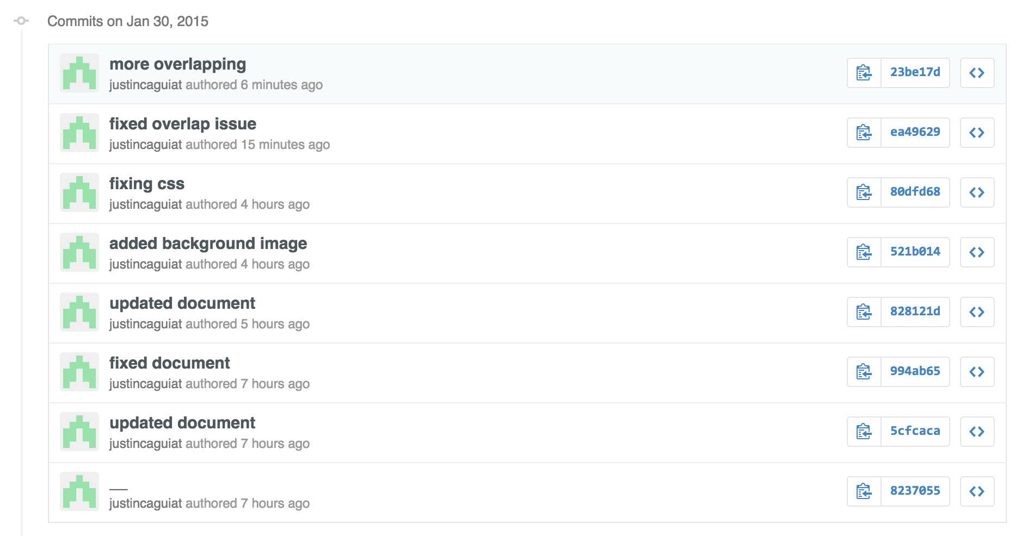

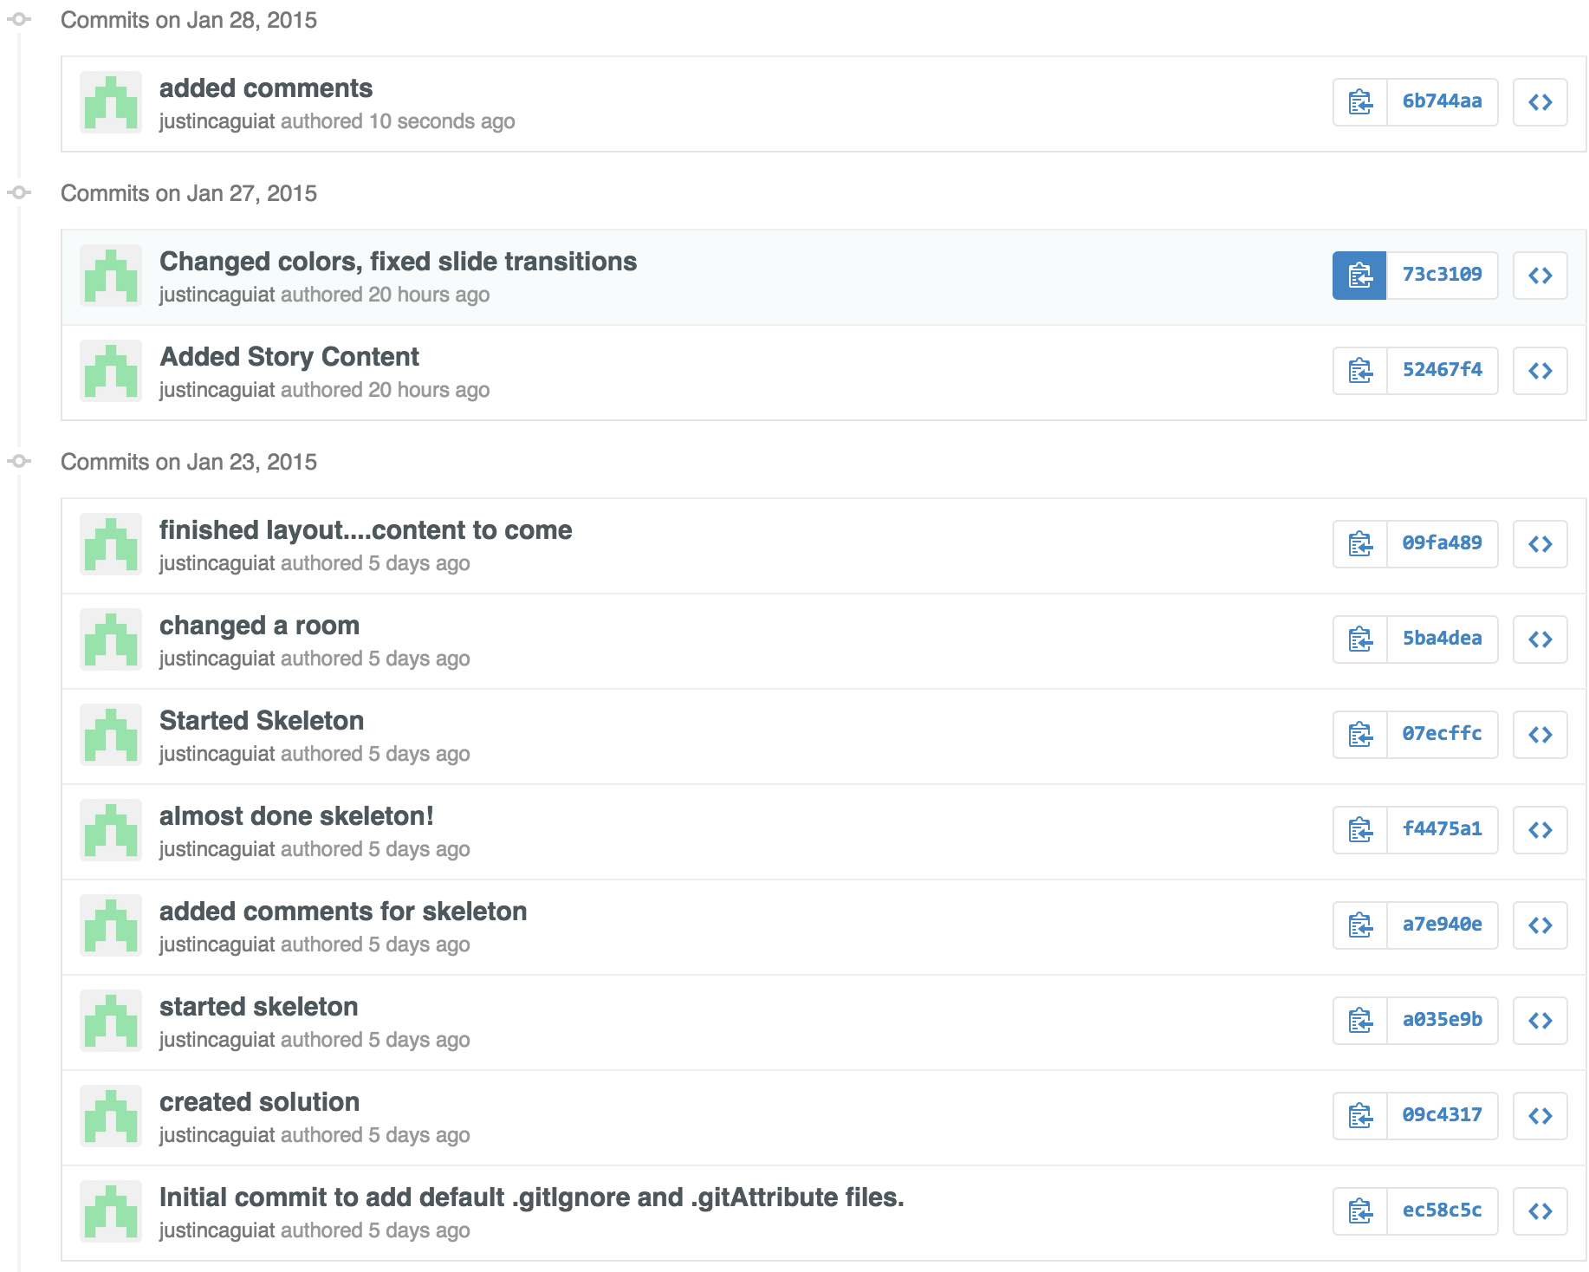

# Game Overview

*A story based game where the player wakes up in an unknown place and has to make life or death decisions to escape.*

# Game Play Mechanics

*Using ImpressJS the game is arranged on various slides and depending on what choice the user makes, will determine what slide will appear.*

# Controls

*Mouse click to select options*

# Interface Sketch

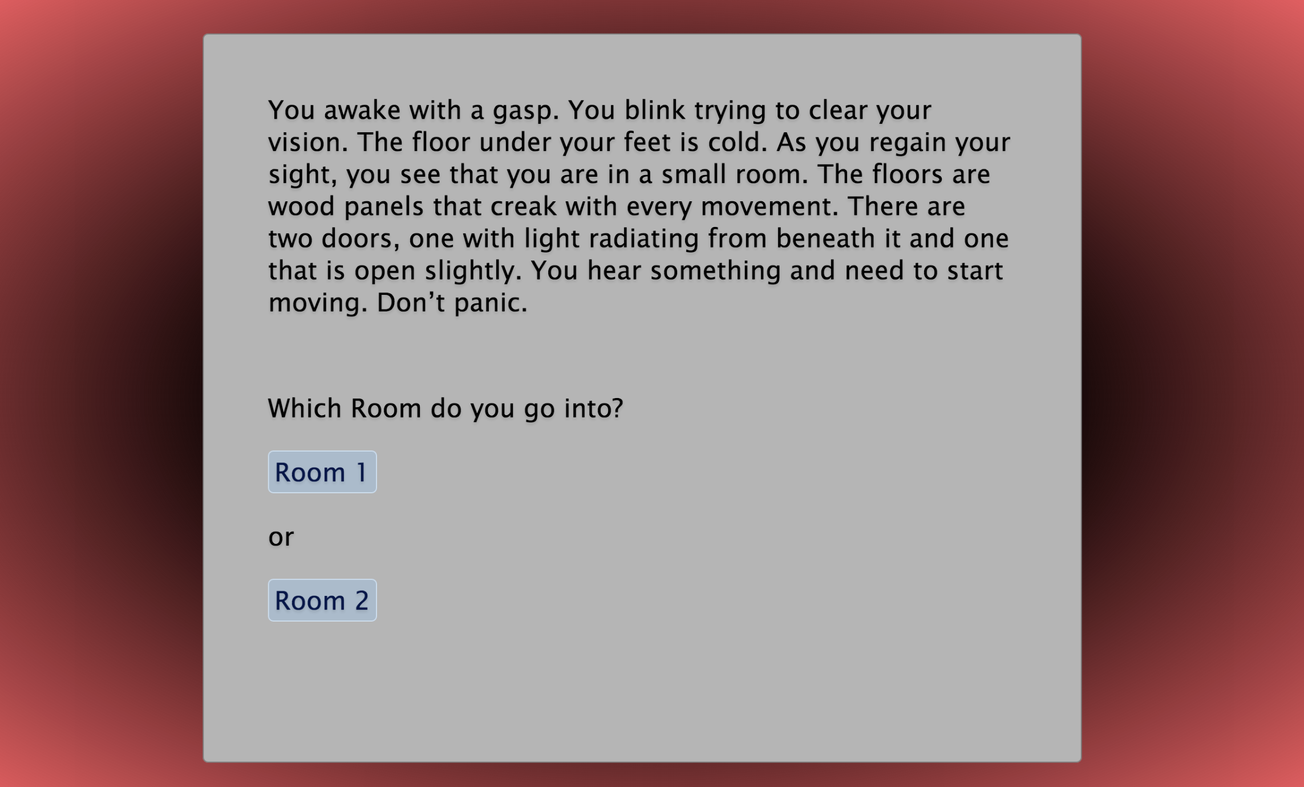

# Game World

*You are in an unknown place somewhere located on the outskirts of a forest. You are alone in a house.*

# Characters

*The main character in this game is unknown; gender, age and name are not mentioned.*

# Enemies

*There is an unknown enemy who is stalking you throughout the story*

# Mind Map of levels

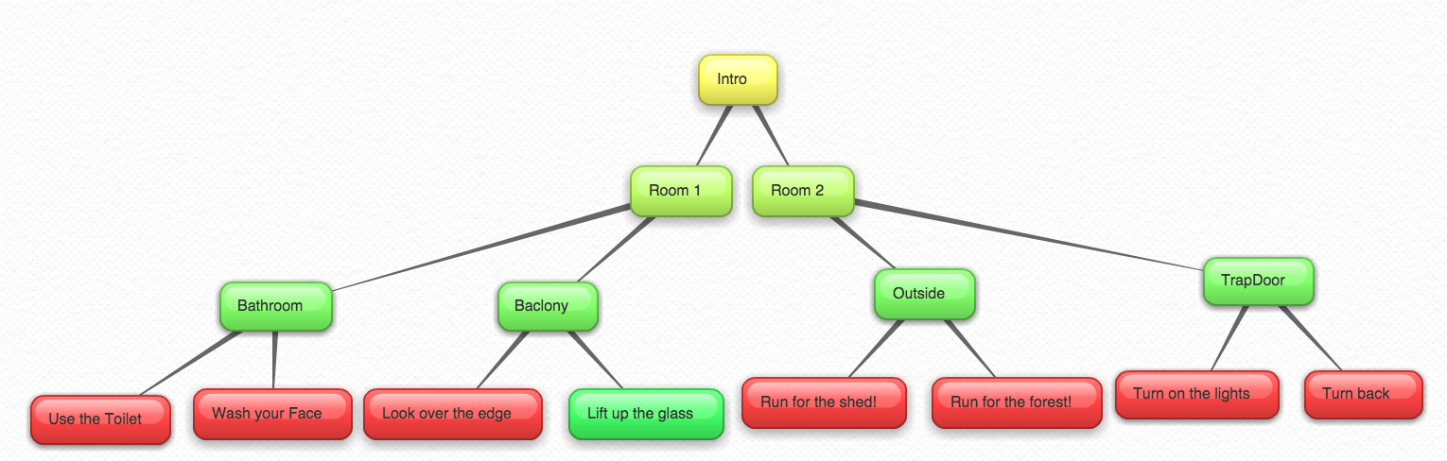

# Story Index

**Intro**

You awake with a gasp. You blink trying to clear your vision. The floor under your feet is cold. As you regain your sight, you see that you are in a small room. The floors are wood panels that creak with every movement. There are two doors, one with light radiating from beneath it and one that is open slightly. You hear something and need to start moving. Don’t panic.

**Room1**

You slowly walk into the next room. You look around you and notice that the room is everything but a couch and a barred window. You don’t know why you are here or how you got here but you need to get out. There is something here. Something is stalking you. You look to your left and see a door out to the balcony and to your right is a bathroom. You know what the right option is but you still consider going in the bathroom.

**Room2**

You stumble into the next room and see that it is much brighter in here. You hear a large bang as the door slams behind you. You quickly turn around and see nothing. You frantically look around and still see nothing. Directly in front of you there is a set of stairs that might go outside. You look down and see a trap door that seems to be unlocked. Even though going deeper into house seems like a bad idea, you still consider it to be an option.

**Balcony**

You step out onto the balcony. There isn’t anything out here other than an upside down glass and an old wooden railing. You hear something below the balcony and something inside says it’s a good Idea to look over the edge. There also appears to be something beneath the glass.

**Bathroom**

Against your better judgment you went into the bathroom. The only thing to do in here is use the toilet (which is surprisingly working) or to have a drink of water.

**Outside**

You make it outside and the light hurts your eyes. You stop to think, but know you don’t have much time. You can either go to the forest or run for that shady looking shed.

**Trapdoor**

You open the trapdoor and go down the stairs its dark. You look around and see a dark silhouette to your left is a light switch. Turning around seems like a better idea.

**Look over the edge**

You look over the edge and before you know what happened, you are pulled over the edge by something with claws. You hit the ground hard and try to get up. Before you are able to run, what pulled you over the edge lunges at you. You are dead.

**Lift up the glass**

You lift up the glass and see that there is actually nothing under the glass. That thing that was following you climbs over the balcony and devours you. You are dead.

**Use the toilet**

Just as you are about to sit on the toilet, a creature bursts through the door and kills you. You died with your pants down… Shouldn’t have done that.

**Wash your face**

You turn faucet on and no water comes out. You feel something penetrate your chest. You are dead.

**Run for the forest**

You sprint as fast as you can to make it to the forest. You escape and find a near by group of travellers who provide you with food and shelter. You live with them for the rest of your life. YOU WIN!

**Run to the shed**

You make it to the shed and go inside. You are ripped to pieces by 50 hanging chain saws that were conveniently on.

**Turn on the light**

The silhouette turns out to be the beast stalking you and eats you alive. You are dead.

**Turn back**

The beast was behind you and mauls your face. You are dead.